Week 5 portfolio and reflection

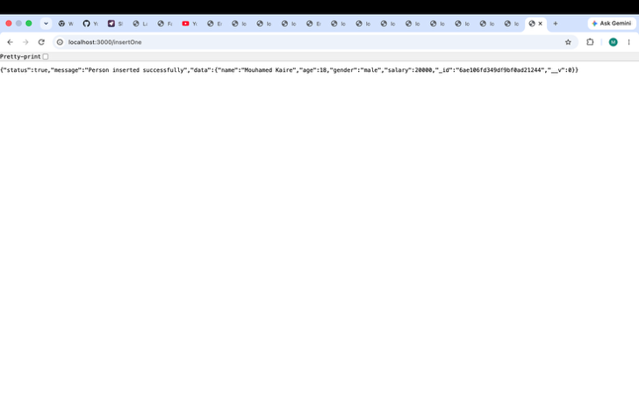

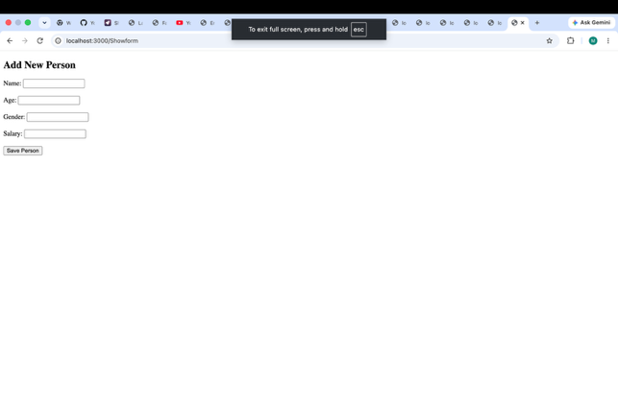

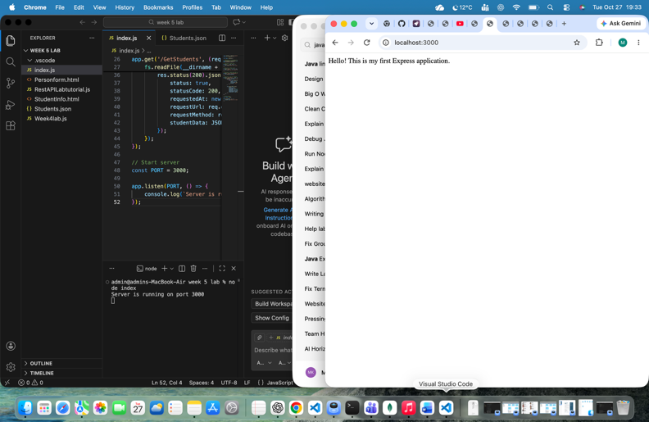
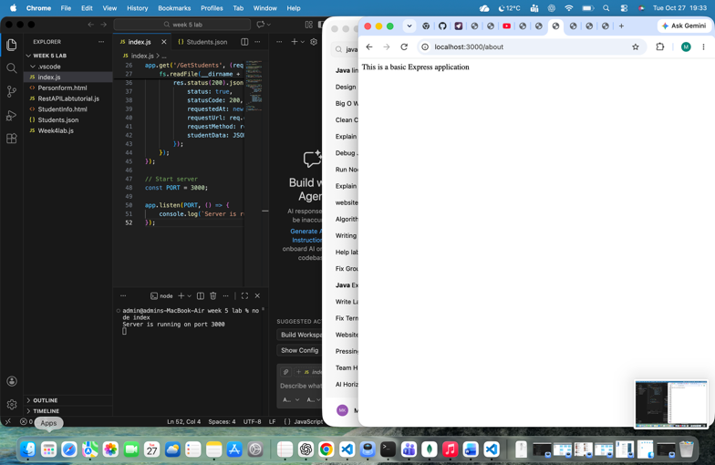

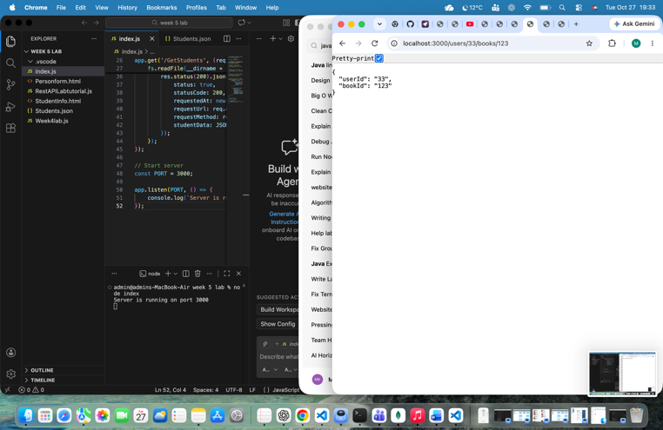

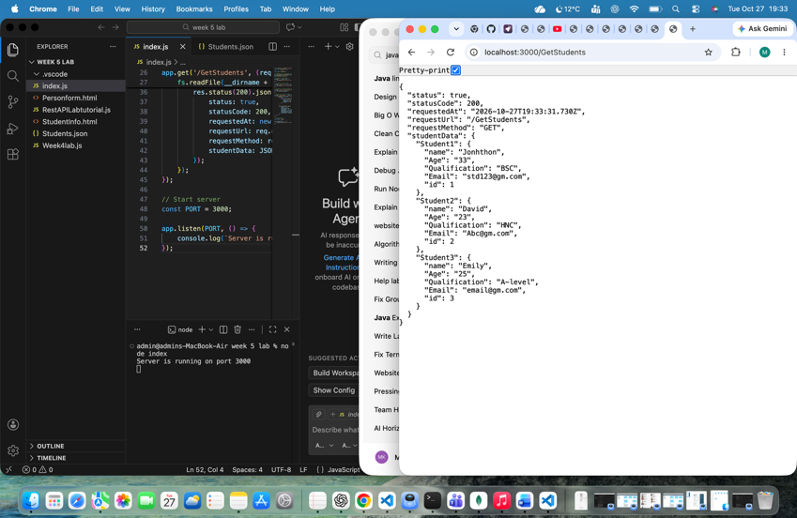

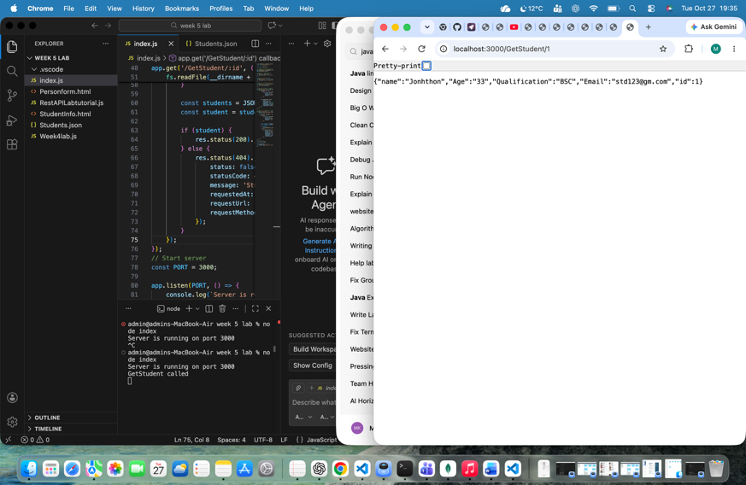

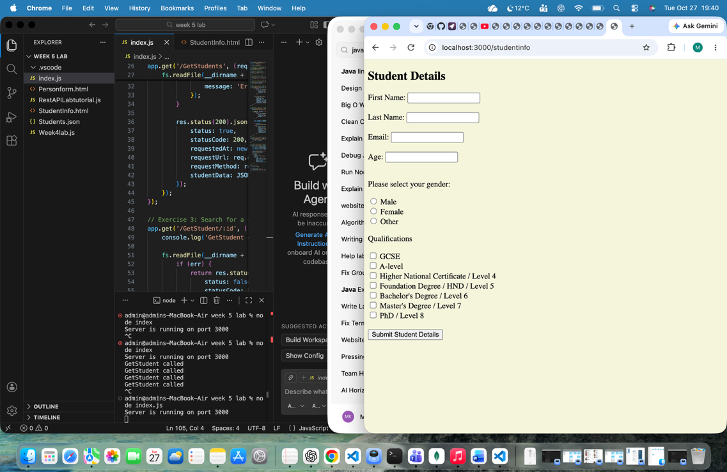

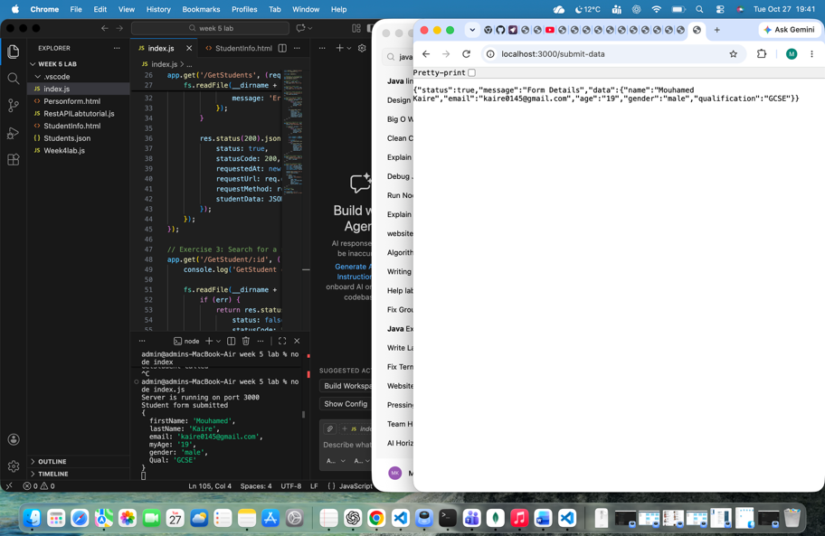

GitHub week 5 link https://github.com/kaire0145-art/CN5006/tree/main/week5
During this lab session, I learned how to use Express.js to develop a REST API and how it can handle HTTP requests such as GET and POST. I also learned how to create different routes to retrieve information, submit form data and communicate with a MongoDB database. Using Mongoose made it easier to create schemas, insert documents, search records, count documents and update or delete data.
I connected Express routes to MongoDB functions by importing the functions from the Week4Lab.js file into index.js. I then created API endpoints that called these functions when a request was received. For example, the /persons route called the findAll() function to retrieve records from MongoDB.
One challenge I encountered was a duplicate function declaration error caused by an incorrect import in Week4Lab.js. I resolved this by removing the unnecessary import and keeping the database connection in index.js. I also learned how to configure the correct local MongoDB connection.
To create the insertMany REST API URL, I first defined the insertMany() function in Week4Lab.js, exported it, imported it into index.js, and created a POST route at /insertMany. Finally, I tested the endpoint using the terminal and confirmed that multiple records were successfully inserted into MongoDB.

